
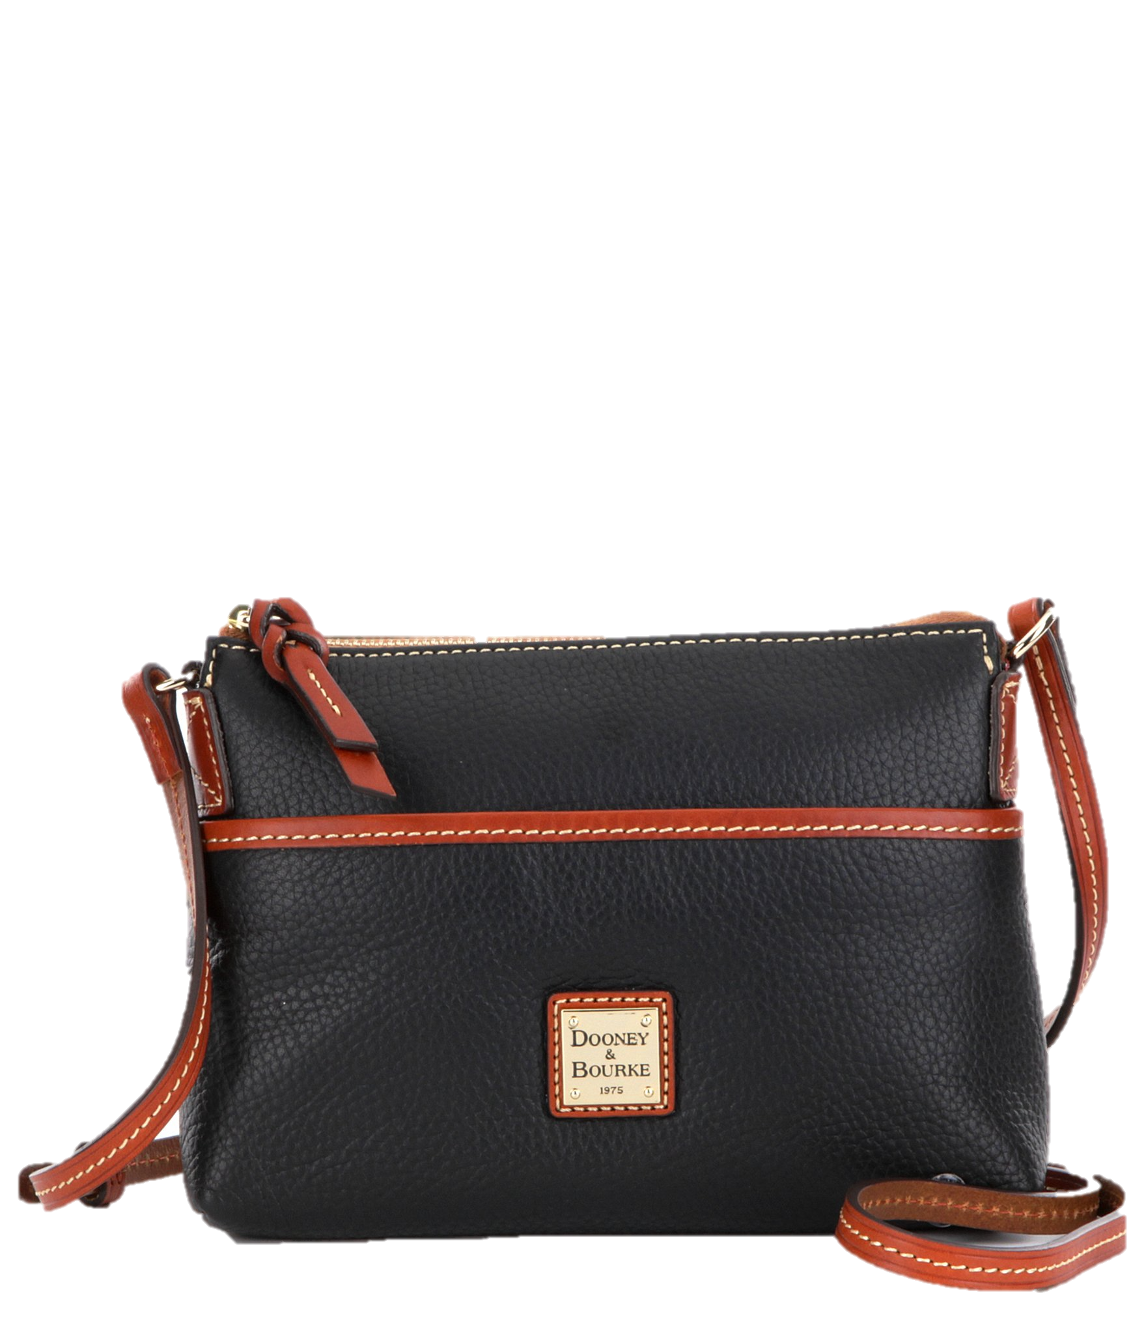
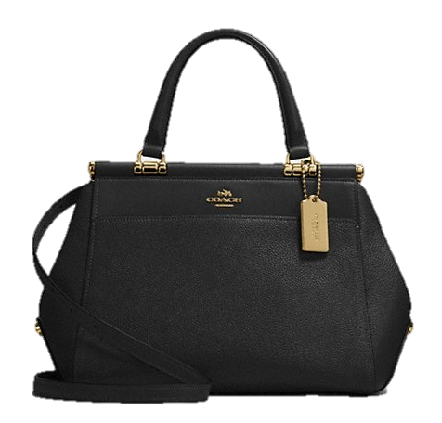
Purses and Totes Bingo
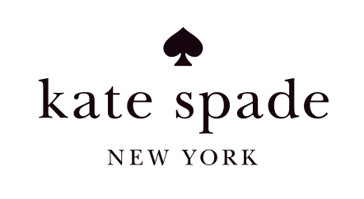

Featuring:
-Michael Kors
-Kate Spade
-Coach
-Vera Bradley
-Dooney & Bourke
AND MORE!

Pulls Tabs
50/50 Raffle
When?
Sunday February 23, 2020
Doors open at 12pm
Bingo begins at 1pm

Where?
Ridge Volunteer Fire Department
13820 Point Lookout Road
Ridge, MD20680

Price?
$25 Advance Tickets
$30 at the Door

*All proceeds to benefit Ridge Volunteer Fire Department Auxiliary*
For Reservations and to pre order tickets, contact Lauren Fairfax 301-904-9408.
Pre-orders and reservations must be submitted by February 17, 2020

Food will be for sale by the Ridge VFD Auxiliary.

Reserved tables for 6 or more for advanced sales only.

*No children permitted unless they have their own ticket and are accompanied by an adult! Tickets are non-refundable. There will be only ONE ITEM won per game*

